**Chatter , win , hold , carry , spread , engage , fly , juicy , pleasantries , news, open , draw , lose**

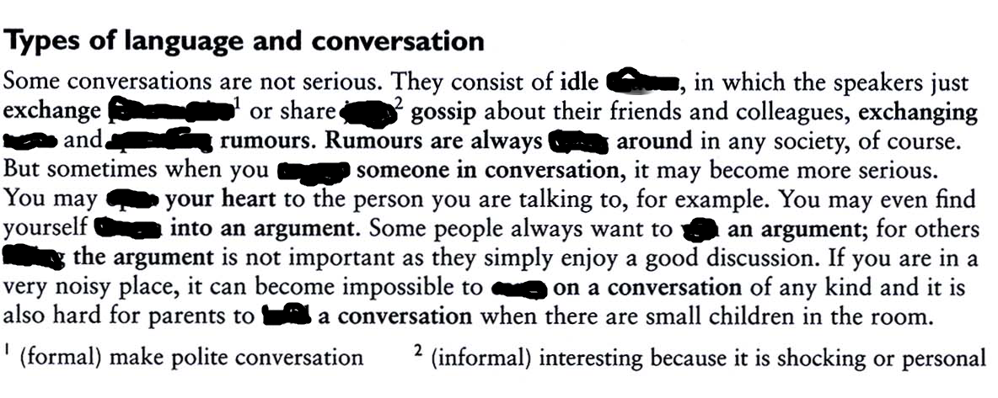

**Raise, bring , take , broad , bombard , drop , overstate , alter**

